CAS PY 106

Lecture Note 23

1. Adding Waves: superposition
2. When more than one wave is traveling in a medium, the waves simply add together
3. The principle of superposition: Net displacement of any point in the medium is the sum of the displacements due to each individual wave
4. 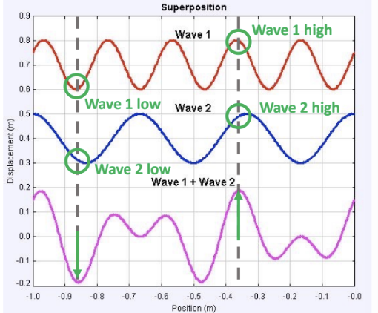
5. Wave Reflections
6. What happens when a wave hits a wall?

Depends on the wall!

1. Hard wall: points on wall don’t move (end of string is a fixed end)
2. Soft wall: points can move (end of string is a free end)
3. Standing Waves
4. Forget a moment about wave reflections… let’s just consider identical waves traveling in opposite directions
5. The result is a superposition wave that does not travel one way or another
6. This sum can be written as:

Y = 2A \* sin(kx) \*cos(wt)

1. 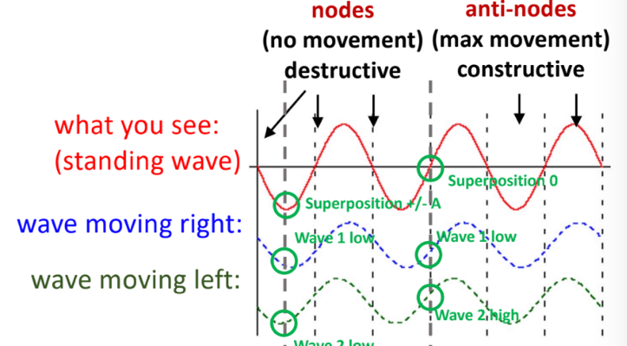
2. Distance between a node and nearest antinode is wavelength/4
3. General Rule for strings and pipes
4. Fixed end is always a node (no movement)
5. Fixed end of a string or metal rod
6. Closed end of pipe
7. Free end is always an anti-node (max movement)
8. End of string or rod that can vibrate
9. Open end of a pipe
10. Standing Waves: string fixed at both ends
11. All stringed musical instruments have strings fixed at both ends
12. When they are played, you hear a combination of the fundamental, or resonant, frequency and the different harmonics
13. 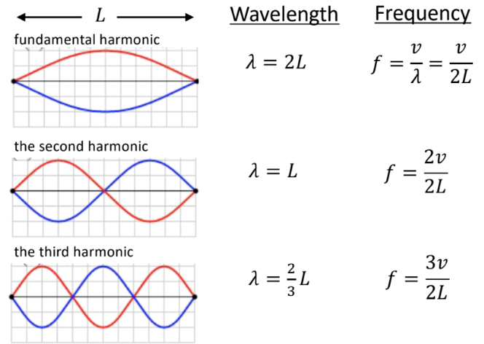
14. 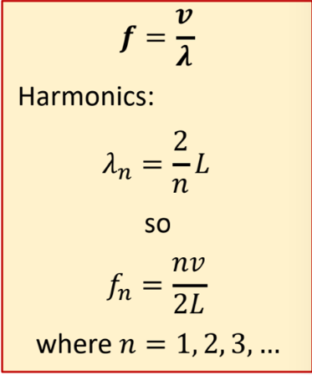
15. If you change L, the string’s frequencies change
16. Longer L: lower frequency note
17. Shorter L: higher frequency note
18. If you change mass per unit length of string(u), the string’s frequencies change
19. Thin string 🡪 v increases, higher frequency notes
20. Thick string 🡪 v decreases, lower frequency notes
21. Standing waves in a pipe
22. Imagine that you create a longitudinal disturbance in air near the open end of a pipe
23. 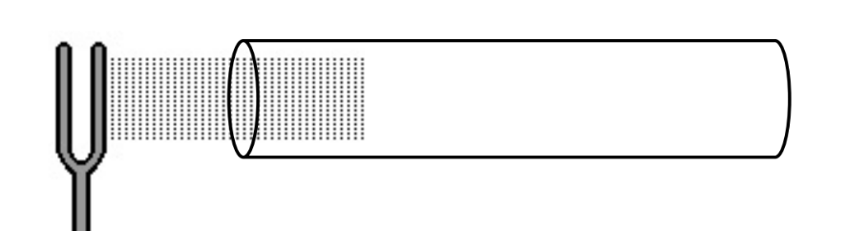
24. The closed end of the pipe behaves as a node for the standing wave in the pipe. Just like the fixed end of a string
25. The open end of the pipe behaves like an antinode, where the displacement of the air is maximal
26. 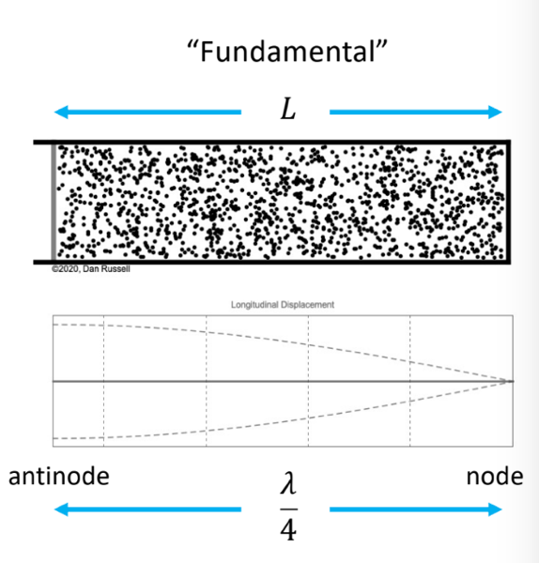
27. Fundamental Frequency:

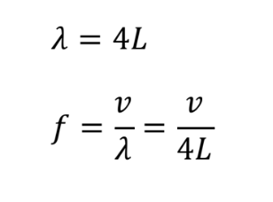

1. 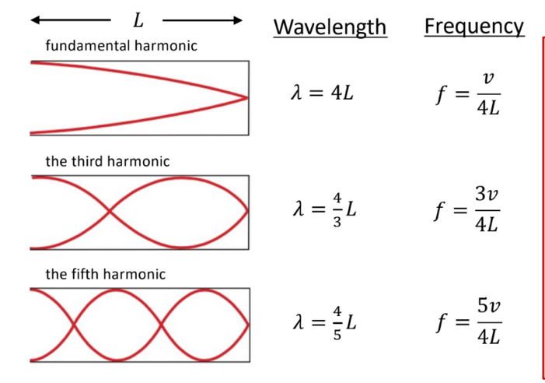
2. 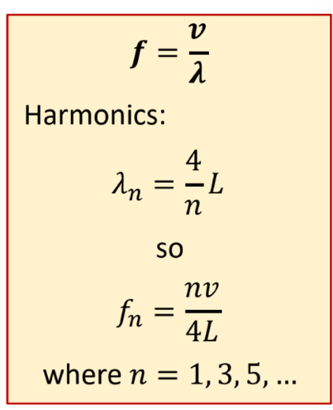
3. Standing waves in a pipe (open at both ends)
4. 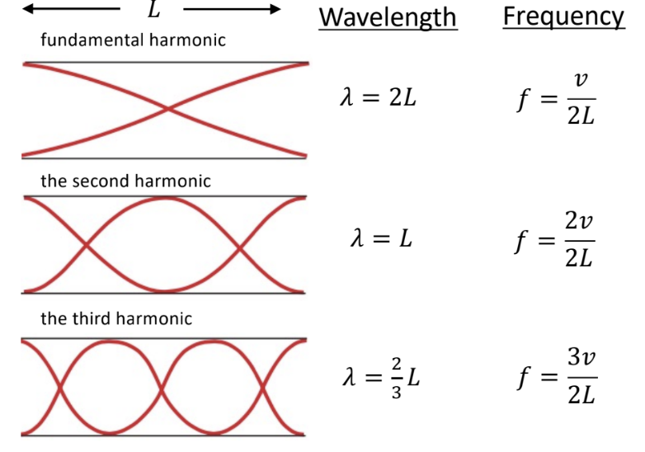
5. 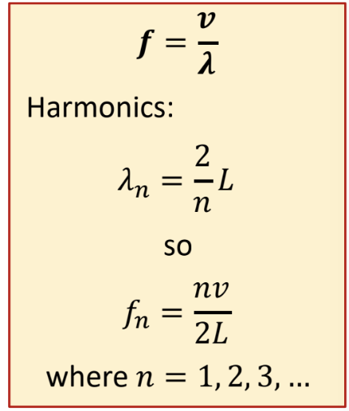
6. Equations are identical to standing wave on a string with both ends fixed